Alarm: ID 56: Flexi PLS Case
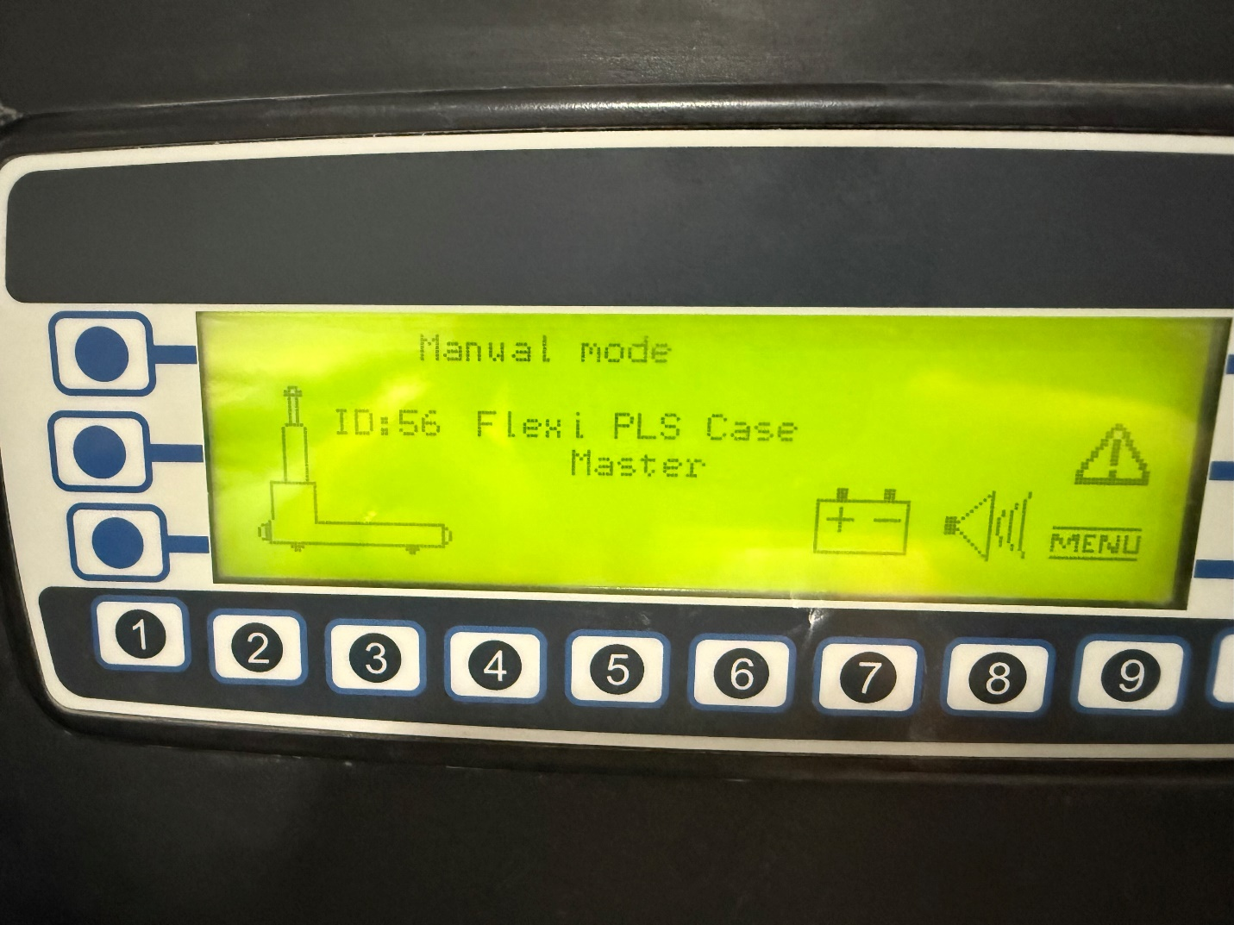
How To Fix:
This alarm indicates a problem with the remote.
To resolve:
- Inspect the remote to ensure all functions are working correctly.
- If necessary, replace the remote.
To clear the alarm and resume normal operation:
- Perform the automatic sequence:
  - Automatic Mode
  - Press the Blue button
  - Press the Green button

